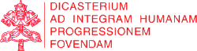

IHD News Anno I, N. 4
Integral Human Development



«Steps on the path of good»

VIDEO
____________
Ad limina visit: Bishops of Nigeria
The Nigeria Catholic Bishops' Conference paid a visit to our Dicastery, on May 2nd.
Card. John Olorunfemi Onaiyekan, Archbishop of Abuja, speaks about the idea of Integral Human Development and its implementation in the Nigerian Church and society.

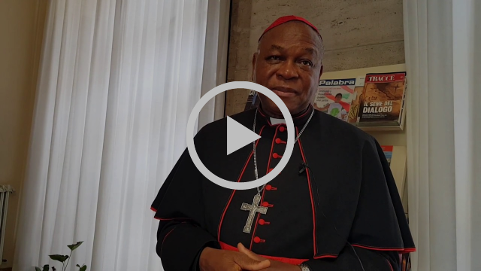
H. Em. Card. John Olorunfemi Onaiyekan, Archbishop of Abuja, Nigeria.

LAST MONTH FOCUS

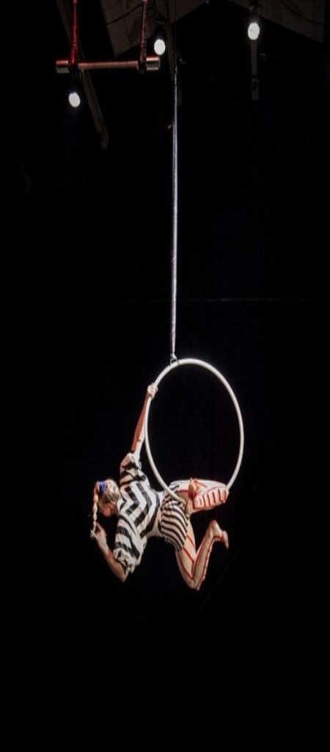

MESSAGE
_______________
9th World Circus Day

"The circus can be called an asset of inestimable human and a cultural value" as "the role of art circus remained unchanged in both the promotion of intercultural and inter-religious coexistence, both in dialogue and in peace building". So Card. Peter Turkson's 9th World Circus Day Message, April 21st.
Citing Pope Francis, Card. Turkson added that the circus are "artisans of wonder", and - as John Paul II said - a "frontier laboratory" on the subject of pastoral care, ecumenism and encounter.
HERE the Message

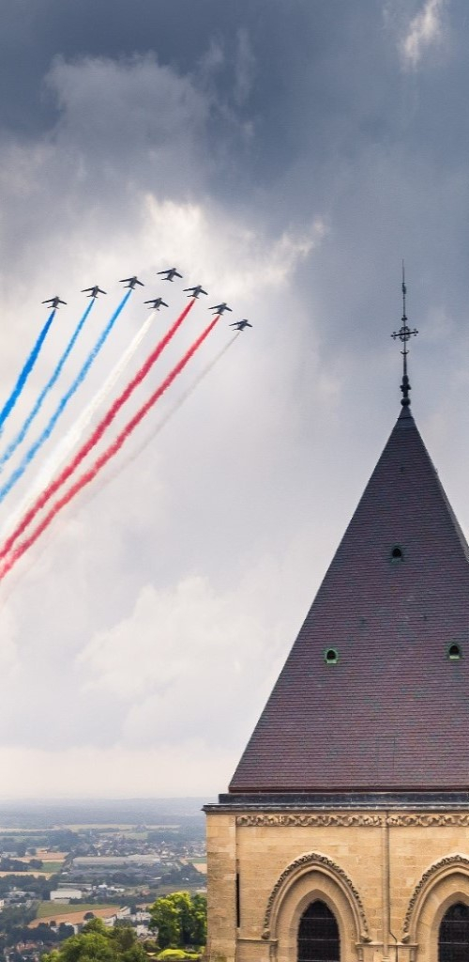

MEETING
_______________
Pastoral challenges in military world
The Secretary of the Dicastery, Msgr. Bruno M. Duffé, on April 26th, met a delegation of French paratroops from the city of Carcassone - accompanied by their military chaplain, Fr. Bertrand Lorentz - in Rome for a bilateral meeting with the Swisse Guard.
Participants talked about the Holy See's commitment to the promotion of peace, the present challenges of military ordination, regarding also the promotion of Christian life in the military world.

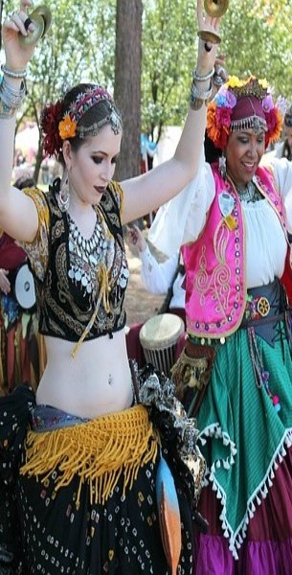

EVENT
____________
Pastoral work for Rom and Sinti

On April 24th and 25th a delegation of the DSSUI partecipated in Frascati (Rome) at the meeting for pastoral workers engaged with Rom and Sinti population in Italy, promoted by the "Migrantes Foundation" of the Italian Episcopal Conference.
About 60 among priests, religious, laity and Rom and Sinti people highlighted proposals and problems, and shared projects end experiences.

NEXT IN AGENDA



DOCUMENT
___________
17 May: Financial ethics
Card. Peter K. A. Turkson, Prefect of DSSUI, will take part in the presentation of the new Document on financial ethics, promoted by the Congregation for the Doctrine of the Faith, at the Holy See Press Office.

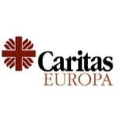

MEETING
___________
7-9 May: Health and young people
The Secretary of DSSUI, Msgr. Bruno M. Duffé, and the Undersecretary, Msgr. Segundo Tejado Munoz, will attend the meeting of "Caritas Europe" (Tbilisi, Georgia, 7-9 May). Participants will particularly reflect how to empower young people on health issues.

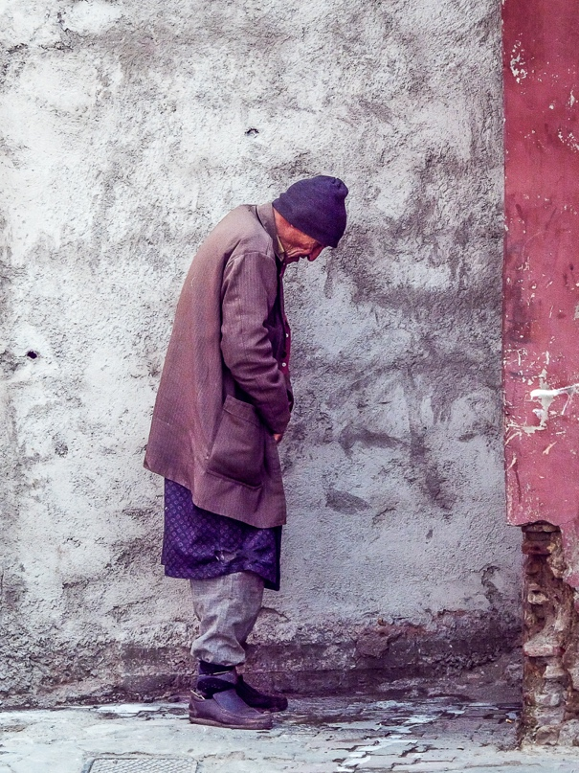

MEETING
___________
21-26 May: WHO Assembly
The Seventy-first World Health Assembly will be held in Geneva from 21th to 26th May 2018. A delegation of the Dicastery will partecipate in the works that will be about: global strategy on public health; WHO's work in health emergencies; health and climate change; access to medecines and vaccines.

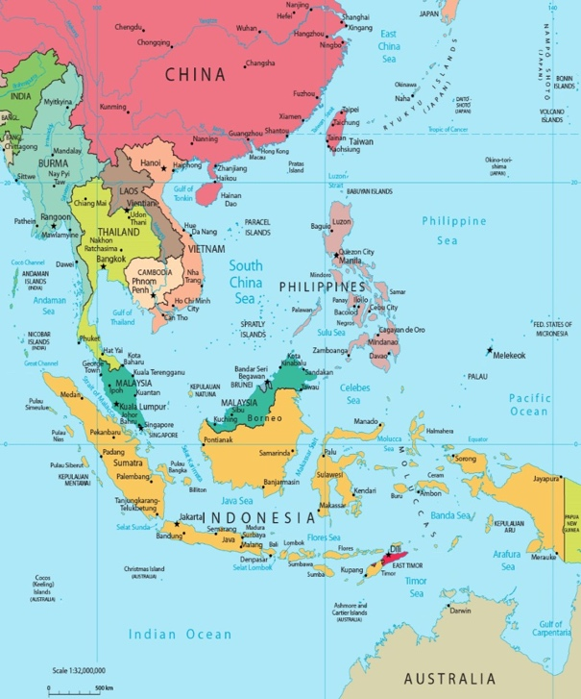

AD LIMINA
___________
7 and 9 May: Myanmar and Taiwan
Bishops from Myanmar and from Taiwan will visit our Dicastery during their quinquennial Ad Limina Visit, respectively on May 7th and May 9th. The topics on the agenda relate to the challenges of the Church and society in their countries.

