

IHD News Anno I, N. 3
Integral Human Development



«Steps on the path of good»

VIDEO
____________
Ad limina visit: Bishops of Pakistan
The Pakistan Catholic Bishops' Conference paid a visit to our Dicastery, on March 15th.
The President of the Conference, H. Exc. Arcbp. Joseph Arshad spoke about the meaning and implementation of Integral Human Development in the Pakistani society.

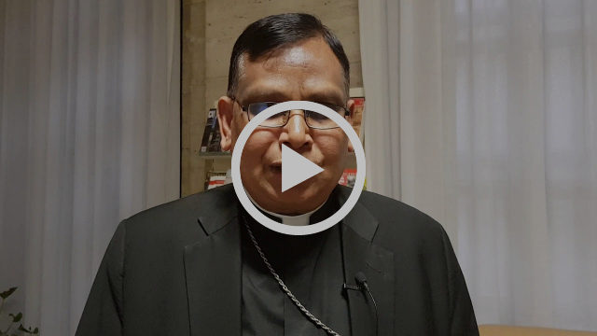
Archbp. Joseph Arshad: how we implement Integral Human Development in the Pakistani society

LAST MONTH FOCUS

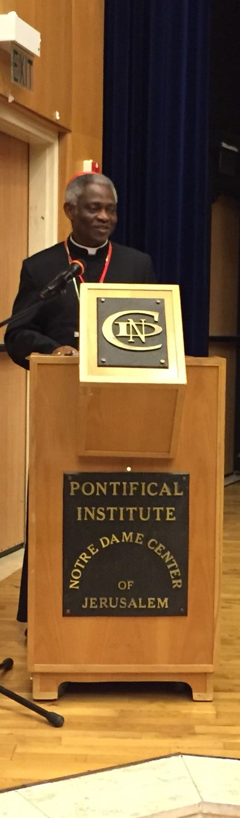

CONFERENCE

_______________
Pontifical Institute "Notre Dame Center", Jerusalem

On March 12th, His Eminence Cardinal Peter K. A. Turkson, Prefect, partecipated in the Conference “An Integral Ecology for an Integral Society: The great Challenge for our time”, held in Jerusalem.
In his speech, Card. Turkson reflected on the evolution and the development of the concept of integral ecology: on how it is inseparably related with the experience of an integral society, based on integral human development.
The text in English [Click Here]

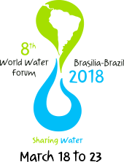

EVENT
_______________
8 World Water Forum - Brasilia
On 8-12 March, the 8th World Water Forum took place in Brasilia - Brazil.
The Secretary of the Dicastery, Rev. Fr. Bruno M. Duffé, took part in the week organized by the World Water Council (WWC), an international organization that brings together all those interested in the theme of water.
Msgr. Duffé spoke as the leader of the Holy See delegation to the Forum and reaffirmed the urgent need for environmental sanitation and a safe drinking water in many countries of the world. On behalf of the Holy See Delegation, he called governments, local administrators, investors, developers, so that water is provided in such a way as to guarantee to all persons a dignified life and integral human development.
Click here to read the Holy See Statement [French]



MESSAGE
____________
World Autism Awareness Day 2018

"Dear brothers and sisters, in the Easter climate which distinguishes this day, I cordially greet all of you, families, parish groups, associations and pilgrims from Italy and from various parts of the world.
I hope that each of you will spend with serenity these days of the Octave of Easter, which extends the joy of the Resurrection of Christ. May you take this opportunity to be witnesses to the Risen Lord’s peace, especially with regard to the most fragile and the most underprivileged. On this matter I would like to assure you of my prayers for World Autism Awareness Day which is being observed today, 2 April".
Together with the Holy Father, who recalled the World Autism Awareness Day, on 2 April, our Dicastery joined the campaign sending a Message on the occasion.

Read the Message in Italian, by His Eminence Card. Peter K. A. Turkson, click here

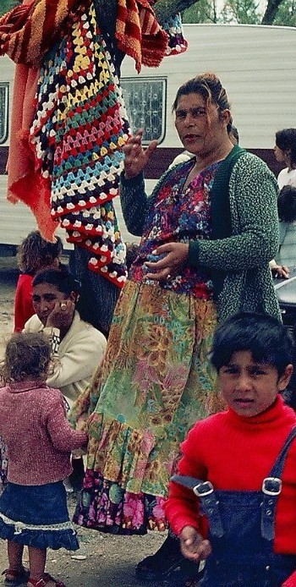

MEETING
____________
CCIT: Annual Meeting of the Catholic Comité for Gypsies

His Eminence Card. Turkson delivered a Message to the annual Meeting of the CCIT (Comité catholique internationale pour les tsiganes),which took place in Banneaux, Belgium on 6-8 April. The Meeting was on the occasion of the International Day for Gypsies “Romanò Dives”
Read the Message in Italian click here

NEXT IN AGENDA

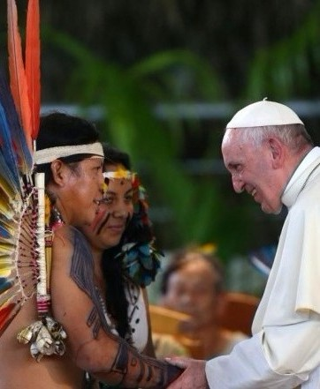

PRE-SYNODAL MEETING
___________
12-13 April
Our Prefect, Card. Peter K. A. Turkson, is taking part in the second pre-synodal meeting for the Pan-Amazonian region, presided by the Holy Father, during which the Preparatory Document will be approved.



MEETING
___________
24 April
The Secretary of the Dicastery, Msgr. Bruno M. Duffé, will welcome in our offices a delegation of military chaplains from Carcassone (France) who are in charge of the Paratroopers Division Pastoral Care.

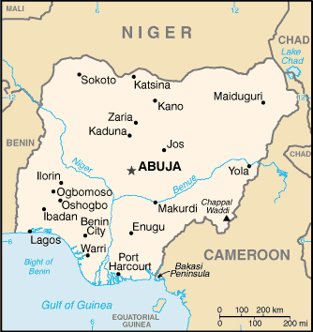

AD LIMINA
___________
26 April
Bishops from Nigeria will visit our offices during their quinquennial Ad Limina Visit.

