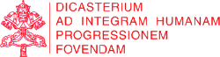

IHD News Anno I, N.1

Integral Human Development

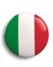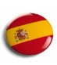

Dear Friends,
As a commitment taken with many of you last year, we are glad to introduce the first issue of the Newsletter of the Dicastery for Promoting Integral Human Development. We desire, through the medium of this Newsletter to remain in contact with all of you, our friends and partners in the promotion of the Church’s Social Teaching and ministry; because, the Motu Proprio and the Statutes of Pope Francis, which underlie and guide the merger of our four dicasteries do not only require us to spread and to promote “...integral human development in the light of the Gospel and in line with the Social Doctrine of the Church”; they invite us to maintain “… relations with the Episcopal Conferences, offering […] cooperation in order that the values concerning justice, peace, as well as the care of creation may be promoted”. (Statutes of the Dicastery for promoting Integral Human Development, Art. 1 §2).
Our mission is our name. In the Encyclical Letter Populorum Progressio(1967), Pope Paul VI introduced the concept of integral development, saying, “Development cannot be limited to mere economic growth. In order to be authentic, it must be complete: integral, that is, it has to promote the good of every man and of the whole man".
In our day, Pope Francis expresses the same idea in these words: “The very concept of person, born and matured in Christianity, helps in the pursuit of a fully human development. Because “person” means relation, not individualism; it affirms inclusion not exclusion; unique and inviolable dignity rather than exploitation; freedom not coercion. The Church never tires of offering this wisdom and her work in the world, in the knowledge that integral development is the road of good that the human family is called to travel. (Audience to the participants in the fiftieth anniversary of “Populorum Progressio”, 4th April, 2017).
The Dicastery wants to promote and help implement, through a holistic development of the human being, effective and ethical responses to problems of justice, war, diseases, poverty in the world and in our communities. It seeks to help respond to the call to a truly integral and human development, a vocation that is destined to be realized fully in Christ.
Peter K. A. Card. Turkson

VIDEO
____________
On February 1st, the Pope’s Worldwide Prayer Network and the Dicastery for Promoting Integral Human Development launched The Pope Video with the February prayer intention dedicated to the fight against corruption.
The video, produced for the first time in collaboration with a Dicastery of the Roman Curia, is a new stage in the process of reflection on the theme launched in June 2017.

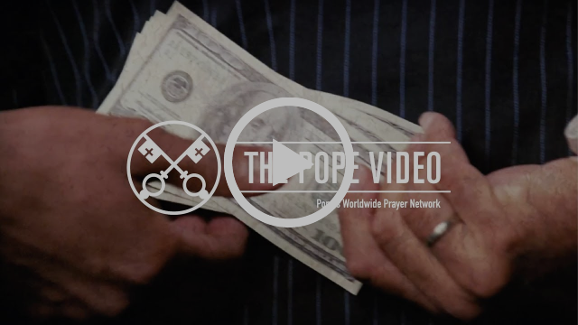
The Pope Video: Say NO to corruption

LAST MONTH FOCUS

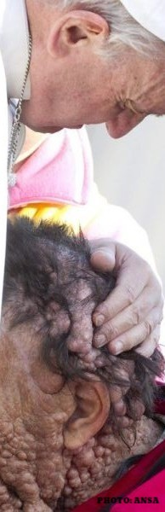

MESSAGE
_______________
65° World Leprosy Day
“No more injustice, discrimination, leprosy in the world!” This is the theme of the the Message from His Eminence Cardinal Peter Kodwo Appiah Turkson, for the 65th World Leprosy Day, held on Sunday 28 January 2018.
On the same day, during the Angelus Prayer, the Holy Father recalled that: "Unfortunately, this disease still affects the most disadvantaged and poorest people. We assure our closeness and solidarity to these brothers and sisters".
On this occasion, AIFO – Italian Association Friends of Raoul Follerau – launched the public awareness campaign #maipiù
Cardinal’s Message: www.vatican.va

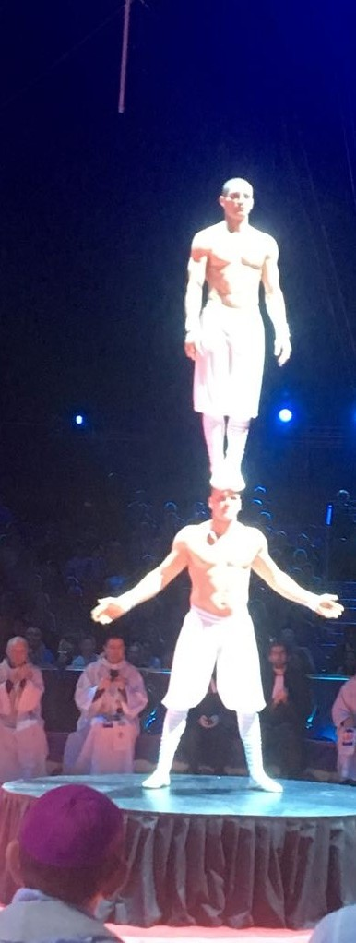

EVENT
____________
Ecumenical Celebration for Circus performers in Monte Carlo
In conjunction with the Week of Prayer for Christian Unity (18-25 January 2018), our office for the Pastoral Service to Itinerant People participated in the Ecumenical Celebration for Circus and Lunapark performers held in Monte Carlo, in the presence of H. S. H. Prince Alberto II and His Grace the Archbisop of Monaco, Msgr. Bernard Barsi.
The celebration was part of the 49th edition of the famous International Circus Festival and took place, on January 22nd, into the Chapiteau de l'Espace Fontveille where all the Monegasque Circus events take place.
HERE read the Welcome Greeting of the Prefect

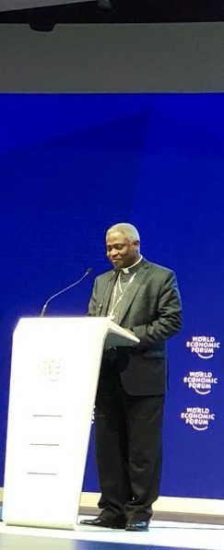

EVENT
_______________
World Economic Forum 2018
From January 23rd- 26th, the Prefect Card. Peter K. A. Turkson took part in the annual WF meeting in Davos.
As in the past, also this year the Holy Father sent a Greeting Message for the opening of the works. In the Message, read by Cardinal Turkson, the Pope reaffirmed that “is vital to safeguard the dignity of the human person, in particular by offering to all people real opportunities for integral human development and by implementing economic policies that favour the family”.
HERE the Pope's message

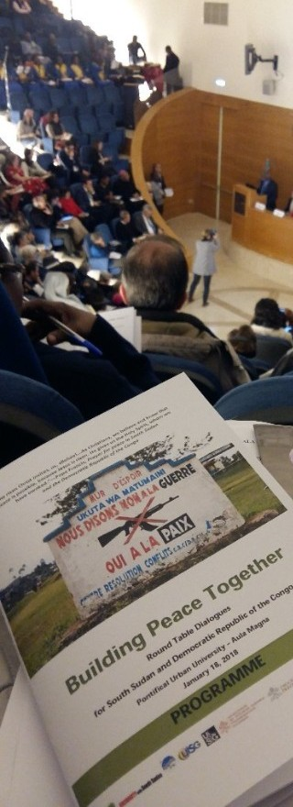

EVENT
___________
Building Peace Together
On January 18th, a Round Table for South Sudan and for the Democratic Republic of the Congo took place in the Aula Magna of the Pontifical Urbaniana University, in Rome.
Hosted by the Dicastery and promoted by the USG/UISG as part of the commitment made by the Union of Superiors General to promote initiatives in favour of peace in the two tormented African nations, the event follows the Vigil of Prayer held in St. Peter’s Basilica, on November 23rd, 2017 in the presence of Pope Francis. The hope of the USG/UISG is to raise awareness on the urgency of building peace and, through dialogue, to suggest concrete actions of reconciliation between the peoples of these two nations.

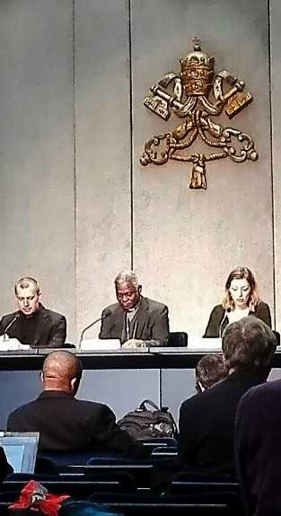

MESSAGE
___________
“Because of the increase of inquity, the love of many will grow cold” (Mt 24:12)
Below is the text of Pope Francis’ Message for Lent 2018, on the theme: “Because of the increase of inquity, the love of many will grow cold” (Mt 24:12). The Message has been presented to the Press on February, 6th .
HERE the text in 10 languages.

NEXT IN AGENDA

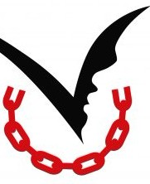

EVENT
___________
8 February 2018
On February 8th, will be celebrated the International Day of Prayer and Awareness against Human Trafficking.
This year's theme is "Migration without Traffiking" to focus on the drama experienced by itinerant populations: migrants, refugees and displaced persons.
The Cardinal Prefect will take part in the prayer vigil organized by the Diocese of Rome in the Basilica of St. John Lateran, in the evening of 3rd February.



MESSAGE
__________________
11 February 2018
On Sunday 11 February the XXVI Day of the Sick will be celebrated all over the world.
The theme is Mater Ecclesiae: "" Behold, your son... Behold, your mother”. And from that hour the disciple took her into his home.... »(Jn 19, 26-27).
HERE the text in 9 languages

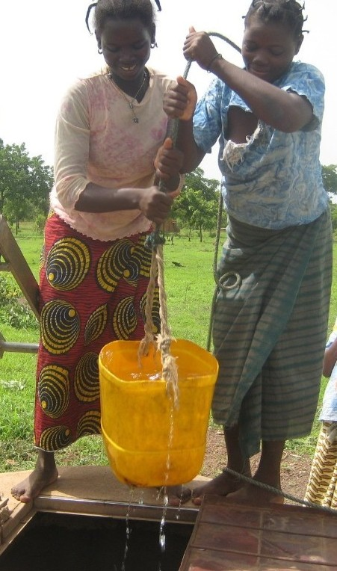

MISSION
___________
End of February 2018
The annual meeting of the Board of Directors of the John Paul II Foundation for the Sahel which carries out projects against drought and desertification will be held in Dakar, Senegal.
Rev. Msgr. Segundo Tejado Muñoz, Undersecretary, will take part in the Meeting as a representative of the Dicastery.

