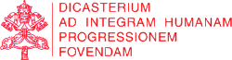

IHD News Anno I, N. 2
Integral Human Development



«Steps on the path of good»

VIDEO
____________
Ad limina visit: Bishops of the Russian Federation
The Dicastery for Promoting Integral Human Development, as well as all Dicasteries of the Roman Curia, regularly welcomes Bishops who come to visit the thresholds of the Apostles and to meet the Holy Father to report on the state of their dioceses or prelatures. These visits are known as Ad Limina Visits and take place each and every 5 years.
In this video, the Archbishop of Moscow, H. Exc. Msgr. Paolo Pezzi, who visited our office during the Ad Limina Visit of the Conference of Catholic Bishops of the Russian Federation, speaks on the meaning and implementation of Integral Human Development in the Russian society.

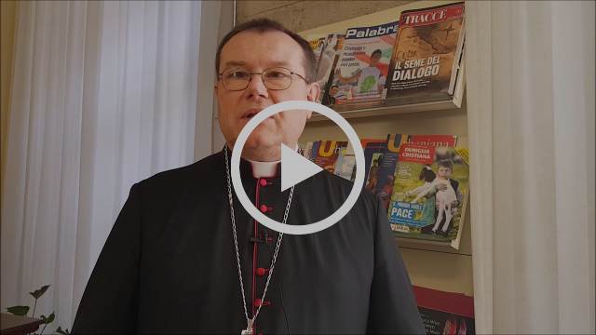
Bp. Paolo Pezzi: the way we implement Integral Human Development
in the Russian society

LAST MONTH FOCUS

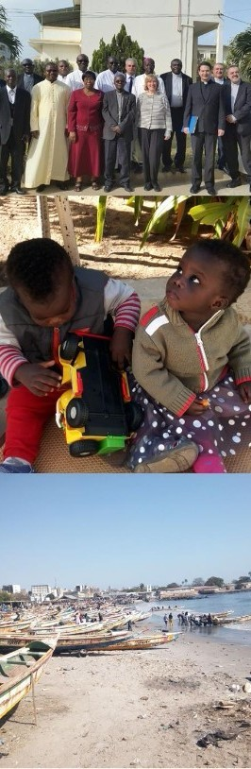

MISSION

_______________
John Paul II Foundation for the Sahel

From February 19 to 23, the annual meeting of the Board of Directors of the John Paul II Foundation for the Sahel, took place in Dakar-Senegal. Since its birth in 1984, the Foundation was entrusted to Cor Unum, now merged into the Dicastery.
Msgr. Segundo Tejado Muñoz, Undersecretary, participated in the BoD. that examined projects still awaiting for financial help.
Projects approved in 2017 were 127, with a total allocation of about 2.3 million dollars; until 2016, financed projects amounted to over 3,200, for a total of approximately 38 million dollars.
Food crises, depletion of natural resources, water in particular, and violence perpetrated on the population of the area, are the main concerns of the Foundation.

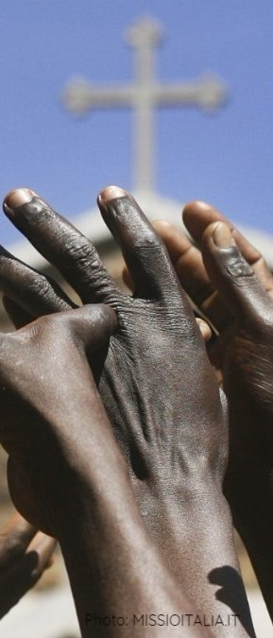

EVENT
_______________
Day of fasting and prayer for Peace

On February 4, during the Sunday Angelus Prayer, Pope Francis had appealed for prayer and fasting for peace in the war-torn nations of the Democratic Republic of Congo, South Sudan and Syria.
On February 23, first Friday of Lent, all women and men of good will joined this initiative.
On November, the Pope called all Catholics to a prayer ceremony in the Vatican; and, in January, our Dicastery organised a Conference with religious missionaries in those troubled countries.

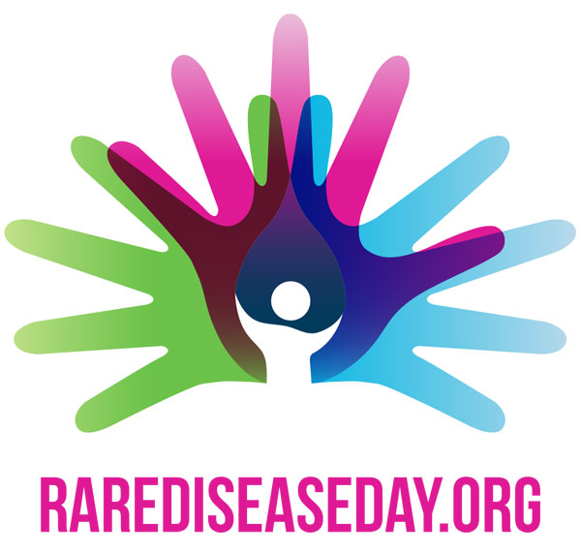

MESSAGE
____________
Rare Disease Day 2018

Since 2008, Rare Disease Day takes place on the last day of February each year.
The main objective of Rare Disease Day is to raise awareness amongst the general public and decision-makers about rare diseases and their impact on patients and families' lives.
Started as a European event, the campaign has progressively become a world phenomenon and our Dicastery, also, joins the campaign sending a Message on this occasion.
The 2018 Message, by His Eminence Card. Peter K. A. Turkson, was delivered on February 28, on the theme: "Show Your Rare, Show You Care".
HERE the Message [ITA]

NEXT IN AGENDA

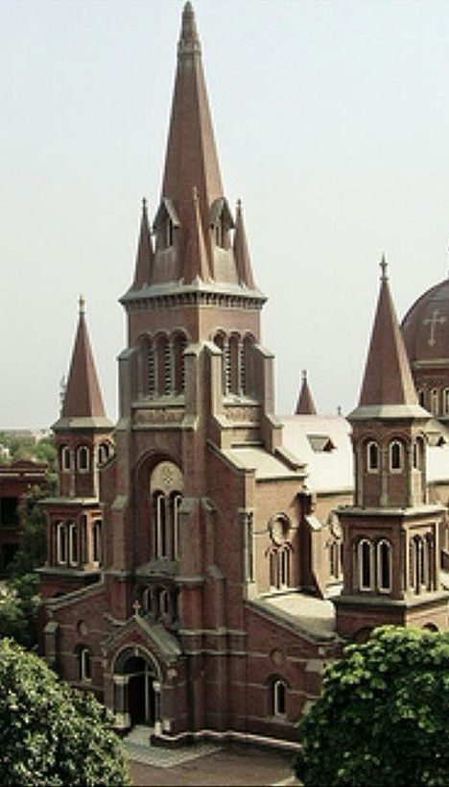

AD LIMINA
___________
15 March
Our Dicastery will welcome a delegation of Bishops from Pakistan, on March 15.
In the same month, Bishops from Slovenia and Vietnam are visiting us during their quinquennial Ad Limina Visit.

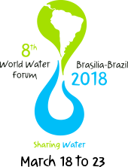

EVENT
__________________
18-23 March
From March 18 to 23, in Brasilia - Brazil, a delegation of the Holy See, headed by Msgr. Bruno M. Duffé, Secretary of the Dicastery for Promoting Integral Human Development, will participate in the 8th World Water Forum.
The event is the world’s biggest water-related event and is organized by the World Water Council.

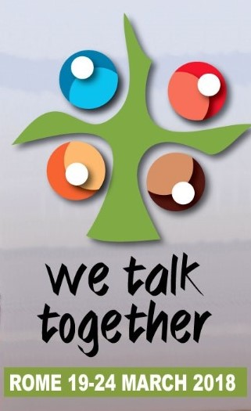

PRE-SYNODAL MEETING ON YOUTH
___________
19-24 March
Our Prefect, Card. Peter K. A. Turkson, will take part in the pre-synodal meeting from March 19-24.
The offical theme of the Synod 2018 (October 3-28, 2018) is “Young People, Faith, and Vocational Discernment.”

