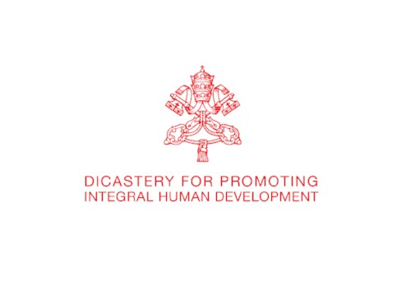

IHD News Anno I, Laudato Si' Special
Integral Human Development

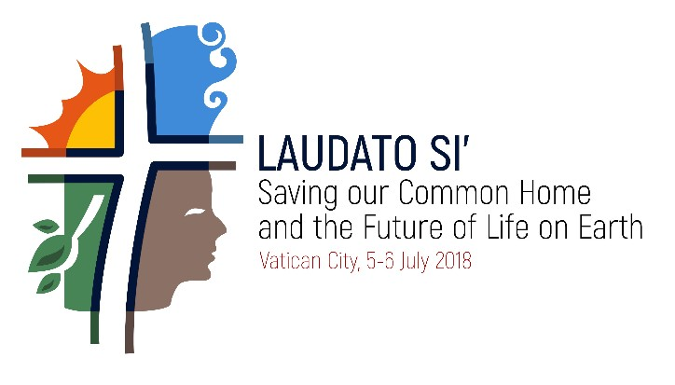



«Steps on the path of good»

VIDEO
____________
The Dicastery for Promoting Integral Human Development is glad to release a short video which summarizes objectives and outcomes of the International Conference "Saving our common home and the future of life on Earth", held in the Vatican , 5-6 July 2018, on the occasion of the third anniversary of the publication of the Encyclical Letter Laudato Si'.
Produced by La Machi and Vatican Media, the video is available in 5 languages on our official Youtube Channel.

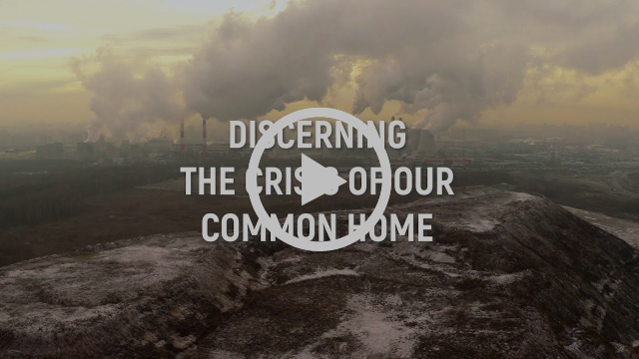
Two-day International Conference "Saving our common home and the future of life on Earth". Vatican City, 5-6 July 2018

USEFUL MATERIAL

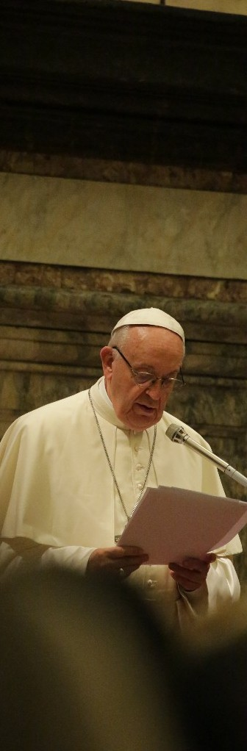

MESSAGE
_______________
The Pope's Address: work for “the radical change"
"All these actions presuppose a transformation on a deeper level, namely a change of hearts and minds. In the words of Saint John Paul II: “We must encourage and support an ‘ecological conversion’” (Catechesis, 17 January 2001). Here the religions, and the Christian Churches in particular, have a key role to play. The Day of Prayer for Creation and its associated initiatives, begun in the Orthodox Church, are beginning to spread among Christian communities throughout the world."
So the Pope to the about 400 participants who met him in the Audience he gave in the Sala Clementina, on July the 6th, second day of the Conference.
HERE the Message

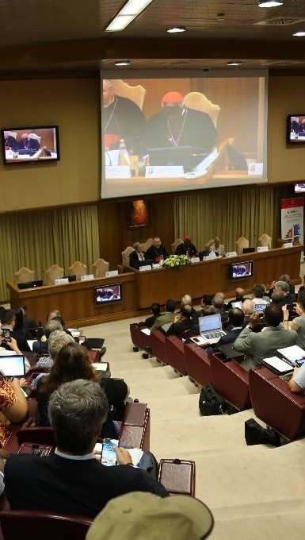

WELCOME
_______________
Opening ceremony
The Prefect of the Dicastery, H. Em. Card. Peter K. A. Turkson, opened the Conference with some remarks on the need to reflect and act together for the care of the Earth to be given to the next generations. HERE the text.
H. Em. Card. Pietro Parolin, Secretary of State, as well, greeted the audience with a welcome address. HERE the text.

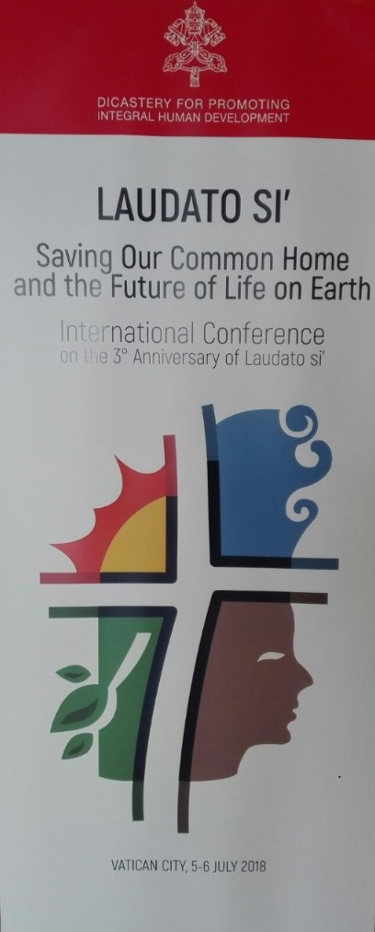

FINAL PRESS RELEASE
____________
A call for ambition on environmental protection
A two-day conference in the Vatican has resulted in urgent calls for action on environmental protection, including climate change. Headed by Pope Francis and including UN environmental chiefs, policy-makers from across the political spectrum, indigenous and youth activists, and people from around the world, the group reflected on next directions for a common action. The address by Pope Francis, available in its full text here, called us to urgently respond to the example of St. Francis in “repairing our common home”. READ ALL

USEFUL TOOL

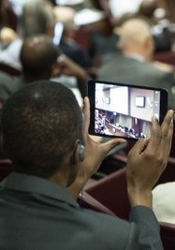

WEBSITE
___________
http://laudato-si-conference.com/
A website dedicated is on-line and contains all useful tools and material: speakers' bios, texts and recordings, programme, updates and pictures.
A survey is offered to all participants in order to receive a feedback to learn what was most helpful about the conference.

