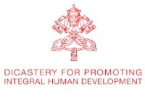

IHD News Anno I, N. 5
Integral Human Development



«Steps on the path of good»

VIDEO
____________
Ad limina visit: Bishops of Venezuela
The Catholic Bishops' Conference of Venezuela paid a visit to our Dicastery, on September the 12th.
H. Exc. Msgr. Victor Hugo Besabe, Bishop of San Felipe, speaks about the idea of Integral Human Development and its implementation in the Venezuelan Church and society, in this critical moment.

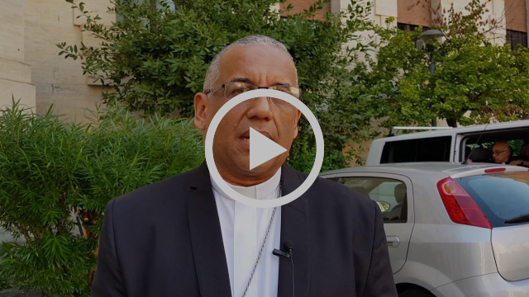
H. Exc. Msgr. Victor Hugo Besabe, Bishop of San Felipe, Venezuela.

LAST MONTH FOCUS

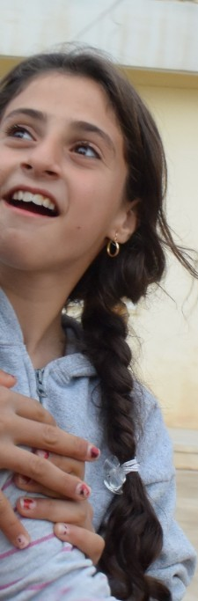

MEETING
_______________
Syria and Iraqi Humanitarian Crisis
13-14 September 2018

The third edition of the survey "You did it for me", regarding the response of Catholic Institutions to the Iraqi-Syrian Humanitarian Crisis, covers seven countries - Syria, Iraq, Lebanon, Jordan, Turkey, Egypt and Cyprus - and presents data in the period 2017-2018.
The main objectives of the survey include obtaining an overall uniform picture of the Church network's response to the humanitarian crisis in Syria and Iraq, and identifying common lines of reflection and shared guidelines for action in the near future.
The Survey has been presented in a Meeting held at Urbanian University, on September 13-14.
SUMMARY OF THE SURVEY [ENG] - [ITA]

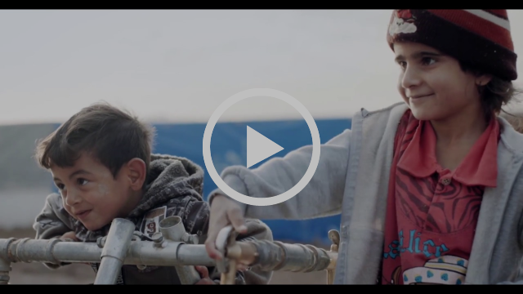
On the occasion of the Meeting for the Iraqi-Syrian Humanitarian Crisis, the Dicastery for Promoting Integral Human Development broadcast a video by Lia Beltrami, Director.



MEETING
_______________
World Conference on Xenophobia, Racism, and Populist Nationalism in the Context of Global Migration
18-20 September 2018
Convinced of the pivotal role that the churches can play in the task of promoting a just and healthier human society, the Dicastery for Promoting Integral Human Development and the World Council of Churches, in collaboration with the Pontifical Council for Promoting Christian Unity, hosted a symposium that brought together ecumenical leaders and experts from around the globe. Participants met from 18-20 September to reflect on and study the current phenomenon of xenophobia, racism and populist nationalism in society, especially in reference to the global migration and refugee crisis.
POPE TO PARTICIPANTS
PROGRAMME
CARD. P. TURKSON SPEECH [ITA]
FINAL MESSAGE
PICTURES

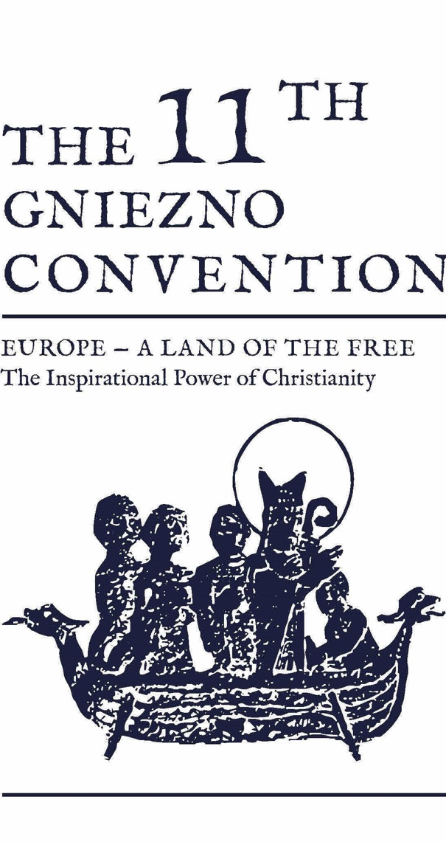

CONFERENCE
_______________
11th Gniezno Convention
23 September 2018
“Europe – a Land of the Free. The Inspirational Power of Christianity” is the subject of the 11th Gniezno Convention, held on September 21-23, 2018. His Eminence Card. Peter K. A. Turkson took part in the Meeting organized by the Archbishop Primate of Poland, H. Exc. Msgr. Wojciech Polak, under auspices of the President of the Republic of Poland Andrzej Duda.
In his Concluding Remarks "“Pain of the World is also a Pain of the Church”. Christians for a Better World", Card. Turkson highlighted the importance of the attention of the Church for the promotion of all human beings, in situations of degradation, violence and death.
During the homily at the Holy Mass, our Prefect recalled that Gniezno Conventions, in their ecumenical character, are a good example of how to make the European family a community through the witness of the faith and unity of all Christians.

NEXT IN AGENDA



SYNOD
___________
3-28 October
Card. Peter K. A. Turkson, Prefect of DSSUI, will take part in the XV Ordinary General Assembly of Synod of Bishops, on the theme: Young People, the Faith and Vocational Discernment.
INSTRUMENTUM LABORIS

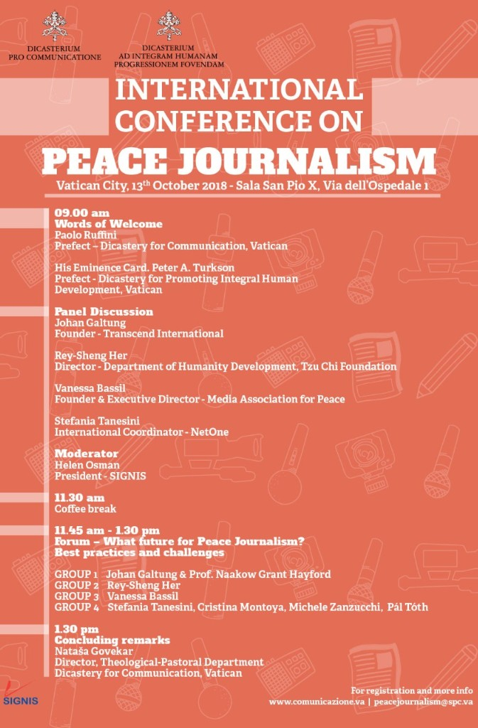

MEETING
___________
13 October
An international conference and a forum on Peace Journalism: a dual event, organized by the Dicastery for Communication with the Dicastery for Promoting Integral Human Development and SIGNIS, that will take place on October 13th on the eve of the Canonization of Blessed Paul VI and Blessed Óscar Romero, who both encouraged communications media to be instruments of reconciliation in the search for truth.
The initiative, to be held in the Vatican, will examine the theme of Peace Journalism, to which Pope Francis dedicated his 2018 Message for World Communications Day. PROGRAMME

